Design Number 3MU/AF 60-01
APPLIED FIREPROOFING
3M Company
3M™ Interam™ E-5, E-54-A and E-5A-4 Series Endothermic Mat
3M™ Fire Barrier CP 25WB+ Caulk
ASTM E 1725 (2008)
ASTM E 119 (2012)
Rating: 1 Hour
Approved for any cable fill
Reference Intertek Design Listing 3MU/AF 60-06 for Ampacity Derating
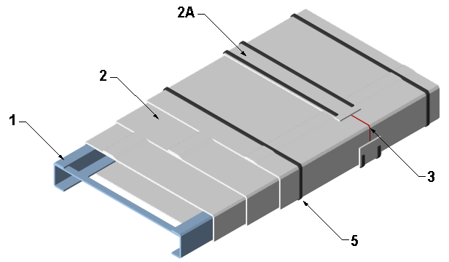

- CABLE TRAY: Use nominal 24 in. wide x 4 in. deep galvanized steel ladder-back cable tray. Friction fit nominal 13/16 in. wide x 13/32 in. deep, 18 GA galvanized steel struts between side rails spaced 12 in. on center (oc) along the length of the cable tray. Use filament tape for additional support if needed.
- CERTIFIED MANUFACTURER: 3M Company

CERTIFIED PRODUCT: Applied Fireproofing

MODEL: 3M™ Interam™ E-5, E-54-A and E-5A-4 Series Endothermic Mat

ENDOTHERMIC MAT: Install 3 layers of foil faced flexible mat tightly around the cable tray (Item 1). Install each piece of mat with a minimum 2 in. overlap onto itself and temporarily hold in place using filament tape if needed.

  - COLLAR: Install nominal 4 in. wide strip of endothermic mat (Item 2) around outer layer of the wrapped cable tray (Item 1). Center collar over butt joints over outer layer and secure using steel banding (Item 5).

- CERTIFIED MANUFACTURER: 3M Company

CERTIFIED PRODUCT: Caulk or Sealant

MODEL: 3M™ Fire Barrier CP 25WB+ Caulk
CAULK: Install caulk between butt joints of endothermic mat (Item 2) on all layers. Alternative use is to fill gaps and voids along seams greater than 1/8 in. wide.
- TAPE: (Not Shown) Apply 4 in. wide pressure sensitive tape with aluminum foil facing to all exposed edges of the collar (Item 2A) as well as the longitudinal (overlap) joints of the endothermic mat (Item 2) on the outer layer.
- STEEL BANDING: Install 1/2 in. wide x 0.020 in. thick stainless steel banding on the outer layer of the endothermic mat (Item 2). Install banding within 1 in. of the edge of collars (Item 2A) and butt joints and maximum 12 in. oc at all other locations.

